# MGMT 435 the Half-Truth of First-Mover Advantage

* First mover advantage is more than a myth but far less than a sure thing. Here is how to tell when it’s likely to occur and when is not
* First-mover status can confer advantages, but it does not do so categorically
  + Much depends on the circumstances in which it is sought

## What kind of first-mover advantage

* First mover advantage
  + A firm’s ability to be better off than its competitors as a result of being first to market in a new product category
  + Durable first mover advantage
    - Improve a firm’s market share or profitability over a long period
  + Non-durable first mover advantage
    - Improve a firm’s market share or profitability in a short-lived
* Firms that succeed in building durable first-mover advantages tend to dominate their product categories for many years
  + From a market’s infancy until well into its maturity
* When a company cannot build a durable first-mover advantage, it may obtain some benefits from early entry

## Industry dynamics are crucial

* Three main ways to create a first mover advantage
  + Creating a technological edge over competitors
    - By starting earliest, first mover s have more time than later entrants to accumulate and master technical knowledge
  + Pre-empting later arrivals’ access to scarce assets
  + Building an early base of customers who would find it inconvenient or costly to switch to the offerings of later entrants
* An early entrant’s prospects depend as much on background factors as they do on the firm’s resources and capabilities
* The most important factors
  + The pace of technology evolution and the pace of market evolution are typically beyond the control of any single firm
* The greater a new product’s or category’s departure from existing products or categories, the more uncertain will be pace of the market’s growth and its eventual shape
* The trajectories of both technological improvement’s expansion in the market and within a product category and that category’s expansion in the market are roughly S-shaped
  + Slow progress ate the beginning yield to rapid progress and the and flattening in the growth rate
    - The precise shape of the S varies from one category to the next

## The likelihood of a first mover advantage

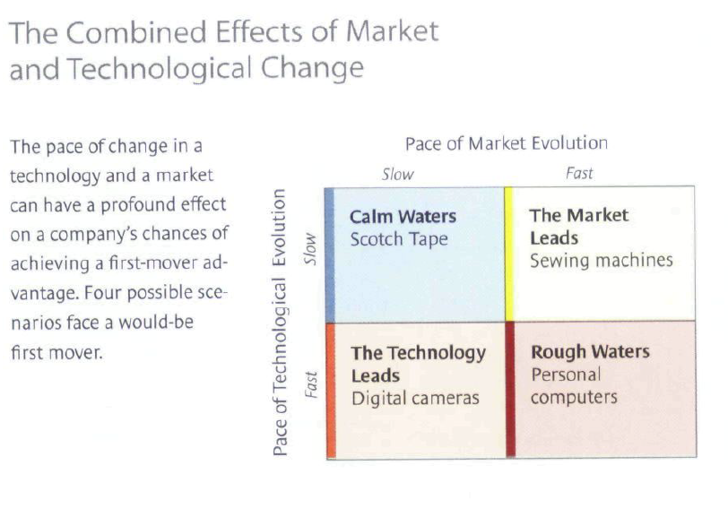

## When the waters are calm

* Gradual evolution in both technology and markets provides first movers with the best conditions for creating a dominant position that is long lasting
* A gradual pace of change in the technology makes it hard for later entrants to differentiate their products from those of the first entrants
* The combination of a slowly changing technology makes company resources less critical than they would be in the other technology and market environment
  + Resources
    - The skill or capabilities and the assets that organizations develop over time
  + Most important capabilities
    - Product development
    - Production
    - Marketing
  + Important asset
    - Brand recognition
  + Others
    - Physical assets
      * Strategic location and financial resources

## When the market leads and technology follows

* A first entrant with limited resources and skills would probably have to settle for a short-term first-mover advantage

## When technology leads and market follows

* A short-life first mover advantage is not likely here
  + Early entrants face many years of flat sales and operating losses and, consequently, the skepticism of stock market analysts
  + Meanwhile, the furious pace of technological change brings in new competitors, who think their improvement will draw customers away from the incumbent and it dated products
  + A durable advantage, for most early entrants as well as most later arrivals, is also unlikely
* Only a company with very deep pockets could enter such market first, survive in the hostile environment, and withstand a considerable delay before obtaining durable first-mover advantage
  + The company also needs a superb R&D capability to keep it at the technological forefront in the meantime

## When the waters get rough

* Both technological innovation and consumer acceptance advance rapidly
  + Leaving first mover highly vulnerable
* It is very difficult for companies to gain durable first-mover advantage
* Product under technology changes very rapidly
  + The items quickly become obsolete
  + Such products are overtaken by versions from new entrants, which are not burdened by maintaining and servicing older product lines and can innovate without fear of cannibalizing prior investments
    - Experts called it vintage effects
* The incumbent tends to be at a disadvantage
  + Since it often lacks the production capacity or marketing reach to serve a rapidly expanding customer base
* A rapid pace of market evolution makes long-term dominance unlikely
  + But it does not necessarily bar a first mover from achieving worthwhile short-term gains
    - Provided it has an acute sense of when to exit
* Achieving a durable advantage under such condition is not impossible
  + A firm’s resources can make a big difference
  + Only a first mover with mighty resources, far superior to those of competitors, has any chance of achieving longer-term first mover advantages when both technology and markets are moving rapidly

## To be or not to be first

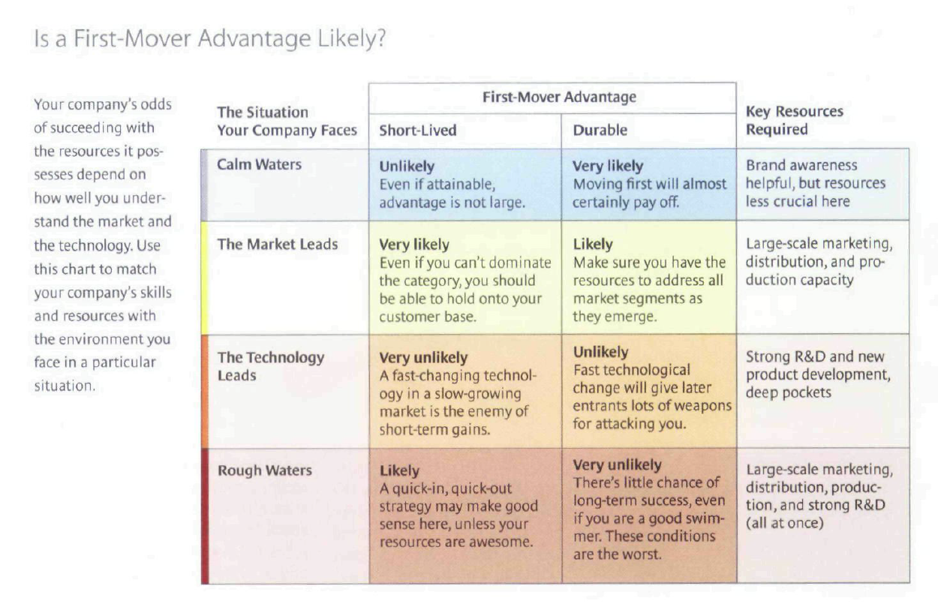

* Key resources
  + Market lead
    - Large-scale marketing
    - Distribution
    - Production capacity
  + Technology lead
    - R&D
    - Deep pockets
* If you have given the wrong type of resources, you may encounter a rough time
* First-mover advantage type
  + Short-term
  + Durable
  + Immediate
  + delayed